INTRODUCTION:

Overviwe:

A vehicle that can be powered by an electric motor that draws electricity from a battery and is capable of being charged from an external source and have an electric motor instead of an internal combustion engine.

The Electric Vehicle (EV) is not new, but it has been receiving significantly more attention in recent years. Advances in both EV analytics and battery technologies have led to increased automotive market share. However, this growth is not attributed to hardware alone. The modern mechatronic vehicle marries electrical storage and propulsion systems with electronic sensors, controls, and actuators, integrated closely with software, secure data transfer, and data analysis, to form a comprehensive transportation solution. Advances in all these areas have contributed to the overall rise of EV’s, but the common thread that runs through all these elements is data analytics.

The new EV’s are combined Electrical storage and propulsion systems with electronic sensors, controls, and actuators, integrated closely with software, secure data transfer to form a comprehensive transportation solution

Purpose:

The results of the analysis can be used to identify trends and patterns in the market, and to make informed decisions about the development and marketing of electric vehicle and EV sales analysis may be conducted by EV companines, publishers, retailers, and other industry professionals. It is an important part of the EV cars industry, as it helps to understand the needs and preferences of consumers and to identify opportunities for growth and innovation.

.



PROBLEM DEFINITION & DESIGN THINKING:

Ideation and brainstorming:

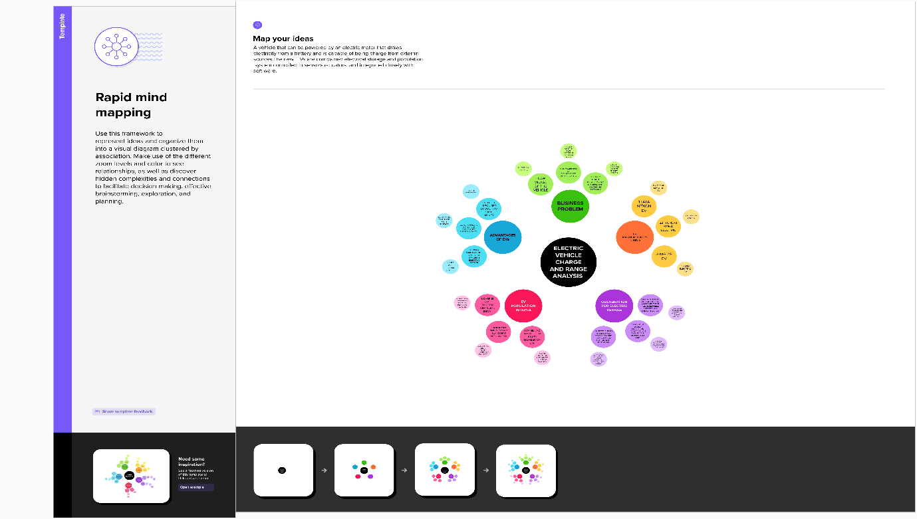

RESULT:

Screenshot:



ADVANTAGES & DISADVANTAGES:

An [electric vehicle](https://intellipaat.com/blog/what-is-electric-vehicle/) is either partially or entirely powered by electricity. Electric cars have fewer moving components and are simple to maintain. They are also incredibly ecologically beneficial because they do not utilize any fossil fuels such as petrol, diesel, or even gasoline.

Electric cars utilize a rechargeable battery pack to power the electric motor rather than a combustion engine. The rechargeable batteries installed within the automobile must be recharged regularly.

These batteries are not only utilized to power the automobile, but they also power the lights and wipers. The most significant advantage of this sort of vehicle is that it does not generate any polluting exhaust.

It lacks the normal liquid fuel components seen in conventional gasoline-driven cars, and maintenance, and is more cost-effective. Some automobile manufacturers have created hybrid versions that can run on both electric and gas power.

Because this notion is new, individuals have little information and awareness of it. As more people begin to use electric vehicles, they will reap the benefits, and demand for EVs is Predicated to rise in the coming months.

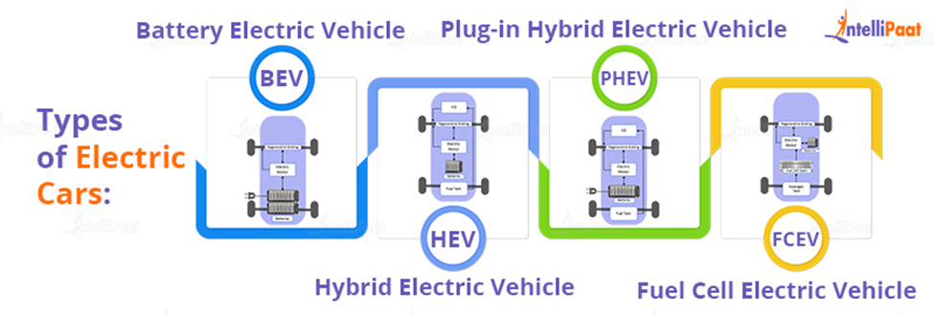

|  |  |
| --- | --- |
| **Advantages** |  |
| * No fuel required so you save money on gas. ... * Environmental friendly as they do not emit pollutants. ... * Lower maintenance due to an efficient electric motor. ... * Better Performance.   **Disadvantages**  Some disadvantages to buying electric cars include the fact that **electric cars can travel less distance than gas-powered vehicles, being able to find EV charging stations, and higher initial costs** |  |
| **Application**  An electric vehicle (EV) is a vehicle that runs on electric energy, powered by a motor. Since they do not emit exhaust gas, they are rapidly gaining popularity in recent years as eco-friendly vehicles. It is equipped with a high capacity lithium-ion battery pack and a high-power motor for driving. The output from the lithium-ion battery is DC current, but the drive motor of electric vehicles is an AC motor. Therefore, an inverter that converts the DC current into three-phase AC must also be installed    A harness is also essential to ensure the safe and reliable transmission of high-voltage electricity. Electric vehicles use the back EMF from the motor to save energy. Therefore, in the development of motors and inverters for electric vehicles, it is also necessary to conduct tests using regenerative DC power supplies |  |

The most common battery voltage installed in electric vehicles is around 300 V to 400 V. Motor, and battery capacities are expected to become high voltage and high power in the future in order to improve driving range.

Matsusada Precision has a models of DC-stabilized power supplies and regenerative power supplies that can be used to evaluate various electrical components such as motors, inverters, and DC/DC converters. We also have a models that can handle high voltages of 800 V or more, so we can make proposals in anticipation of higher voltages

Electric and hybrid vehicles can have significant emissions benefits over conventional vehicles. All-electric vehicles produce zero tailpipe emissions, and PHEVs produce no tailpipe emissions when operating in all-electric mode. HEV emissions benefits vary by vehicle model and type of hybrid power system.

The advanced batteries in electric vehicles are designed for extended life but will wear out eventually. Several manufacturers of electric vehicles are offering 8-year/100,000-mile battery warranties.The National Renewable Energy Laboratory indicates that today’s batteries may last 12 to 15 years in moderate climates (8 to 12 years in extreme climates).

**CONCLUSION**

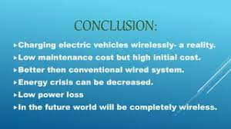

FUTRUE SCOPE:

Electric car manufacturing is getting increasingly popular, and its market share is likely to grow significantly. By 2022, India's GDP is predicted to increase by a staggering 25%.

The best aspect is that, in addition to decreasing pollution, EVs can reduce oil imports by $60 billion by 2030. Currently, imports account for 82 per cent of India's oil requirement. As a result, it is clear how helpful it will be for the Indian economy if the import cost is decreased

**There are no emissions:**

Electric automobiles are being developed primarily because they do not emit any pollution when driving. An electric vehicle is propelled by a battery-powered electric motor. There is no burning of fuel. An electric vehicle does not have an exhaust system. It's the best road transportation solution at a time when global CO2 emissions and air pollution must be drastically cut.

### Access to city centres is unrestricted:

Aside from the fact that more cities are implementing LEZs, these zones are also growing in size and strictness with time. With an electric car, you have limitless access to low-emission zones, now and in the future, wherever and whenever you want.

### Electricity is less expensive than gasoline:

Electricity is less expensive than gasoline and fuel. In this regard, an electric automobile is less expensive than a car with a combustion engine. The most cost-effective solution is to charge at home.

### Comfortable and quiet:

Unlike a combustion engine, an electric motor produces very little noise. As a result, the silence inside an electric vehicle is unmistakable. Additionally, unlike a combustion engine, an electric motor does not produce any vibrations or resonance. The vibration-free and silent drivetrain adds to the relaxation.

### There's no need to switch gears:

### An electric automobile does not have a traditional gearbox, which is another key distinction from a car with a combustion engine. An electric car always works like a car with an automatic transmission, which eliminates the need to shift gears. You also don't have to pay more for it. Driving in busy start-stop traffic in the city or traffic congestion has never been more comfortable, thanks to the quietness of an electric motor

### Requires less maintenance:

Electric drivetrain technology is much simpler than that of a combustion engine. Because only a few sections need to be lubricated, it has far fewer (spinning) parts and fluids. So, as you may have guessed, an electric vehicle requires less maintenance.

### Generate your power:

Having your oil refinery in your garden to make your auto fuel is impossible. It's hardly unexpected, though, that you can create your electricity. For example, solar panels on the top of your home or office building can provide energy. You may further lower your kilometre cost by charging your battery with this renewable energy.

APPENDIX:

Basic code for the html wed design:

|  |  |
| --- | --- |
|  |  |
|  | <!doctype html> |
|  | <html lang="en"> |
|  | <head> |
|  | <meta charset="utf-8"> |
|  | <meta name="viewport" content="width=device-width, initial-scale=2"> |
|  | <title>gaming industries</title> |
|  | <link rel="stylesheet" href="style.css"> |
|  | <link href="<https://cdn.jsdelivr.net/npm/bootstrap@5.3.0-alpha3/dist/css/bootstrap.min.css>" rel="stylesheet" integrity="sha384-KK94CHFLLe+nY2dmCWGMq91rCGa5gtU4mk92HdvYe+M/SXH301p5ILy+dN9+nJOZ" crossorigin="anonymous"> |
|  | </head> |
|  | </head> |
|  | <body> |
|  |  |
|  |  |
|  |  |
|  |  |
|  | <nav class="navbar navbar-expand-lg bg-body-tertiary"> |
|  | <div class="container-fluid"> |
|  | <a class="navbar-brand" href="#">GAMING INDUSTRIES by muthukumar</a> |
|  | <button class="navbar-toggler" type="button" data-bs-toggle="collapse" data-bs-target="#navbarNavAltMarkup" aria-controls="navbarNavAltMarkup" aria-expanded="false" aria-label="Toggle navigation"> |
|  | <span class="navbar-toggler-icon"></span> |
|  | </button> |
|  | <div class="collapse navbar-collapse" id="navbarNavAltMarkup"> |
|  | <div class="navbar-nav"> |
|  | </div> |
|  | </div> |
|  | </div> |
|  | </nav> |
|  | <div class='tableauPlaceholder' id='viz1680954146178' style='position: relative'><noscript><a href='#'><img alt=' ' src='https:&#47;&#47;public.tableau.com&#47;static&#47;images&#47;GA&#47;GAMINGINDUSTRIES&#47;Sheet12&#47;1_rss.png' style='border: none' /></a></noscript><object class='tableauViz' style='display:none;'><param name='host_url' value='https%3A%2F%2Fpublic.tableau.com%2F' /> <param name='embed_code_version' value='3' /> <param name='site_root' value='' /><param name='name' value='GAMINGINDUSTRIES&#47;Sheet12' /><param name='tabs' value='yes' /><param name='toolbar' value='yes' /><param name='static_image' value='https:&#47;&#47;public.tableau.com&#47;static&#47;images&#47;GA&#47;GAMINGINDUSTRIES&#47;Sheet12&#47;1.png' /> <param name='animate_transition' value='yes' /><param name='display_static_image' value='yes' /><param name='display_spinner' value='yes' /><param name='display_overlay' value='yes' /><param name='display_count' value='yes' /><param name='language' value='en-GB' /></object></div> <script type='text/javascript'> var divElement = document.getElementById('viz1680954146178'); var vizElement = divElement.getElementsByTagName('object')[0]; vizElement.style.width='100%';vizElement.style.height=(divElement.offsetWidth*0.75)+'px'; var scriptElement = document.createElement('script'); scriptElement.src = 'https://public.tableau.com/javascripts/api/viz_v1.js'; vizElement.parentNode.insertBefore(scriptElement, vizElement); </script> |
|  |  |
|  |  |
|  |  |
|  |  |
|  |  |
|  |  |
|  | <script src="<https://cdn.jsdelivr.net/npm/bootstrap@5.3.0-alpha3/dist/js/bootstrap.bundle.min.js>" integrity="sha384-ENjdO4Dr2bkBIFxQpeoTz1HIcje39Wm4jDKdf19U8gI4ddQ3GYNS7NTKfAdVQSZe" crossorigin="anonymous"></script> |
|  |  |
|  |  |
|  |  |
|  |  |
|  | </body> |
|  | </html> |
|  |  |
|  |  |
|  |  |
|  |  |
|  |  |
|  |  |
|  |  |
|  |  |
|  |  |
|  |  |
|  |  |
|  |  |
|  |  |
|  |  |